***This tutorial will contain following topics:***

* Salesforce – Reports

# Salesforce - Dashboards

**Salesforce – Reports**

Creating reports in Salesforce is not a very complicated process. The reports are created on top of one or more Salesforce objects. It has the flexibility of applying filters and joining data sets to create sophisticated reports. The interface is called the **Report builder**.

Go to the **Reports** icon in the left bar menu of the Lightning Experience Home Page. Follow the steps below to create a report.

## Step 1

Click on **Create New Report**. Upon clicking, the following screen appears. We choose **Accounts** and click **Create**.

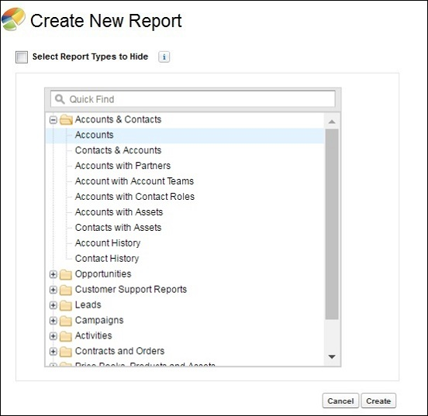

## Step 2

In this step ,we define certain settings for the report and get the resulting rows. We choose "My Accounts" from the dropdown **Show**. It brings all the records owned by the creator of the report. Next we choose the created date filter as **All Time** as shown below. We proceed by saving the report with the name - **Accounts report**.

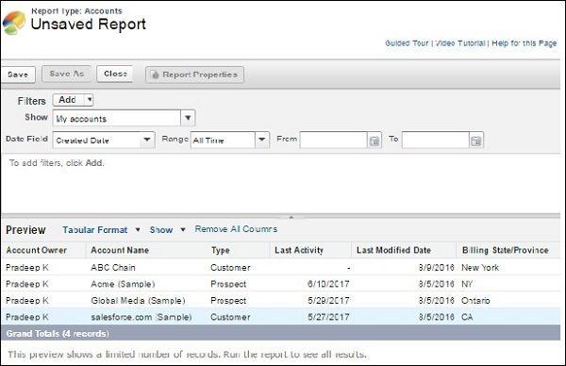

## Step 3

Now, we will apply a filter to the above report. Click on the **Add filter** option in the white space just below the date filed filter. Choose the field **Billing State/Provinces**. Choose the **equal to** operator and type the value NY in the next text box. This filters out the row for NY as shown below.

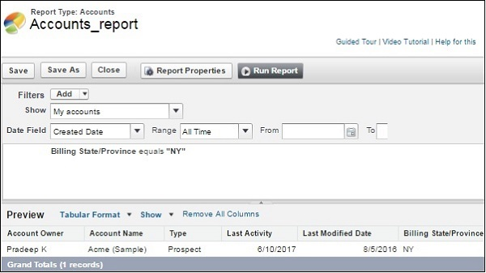

# Salesforce - Dashboards

Dashboards provide more insights than reports as they combine the data from many reports and show a summarized result. Looking at many reports at a time gives the flexibility of combining the results from them quickly. Also summaries in dashboards help us decide on action plans quicker. The dashboards can contain charts, graphs and Tabular data.

Let us now see the steps to create a dashboard.

## Step 1

Go to the Dashboard button on the left menu bar in the Salesforce Home Page. Now, click on the New Dashboard and the following window appears. Fill in the name and description.

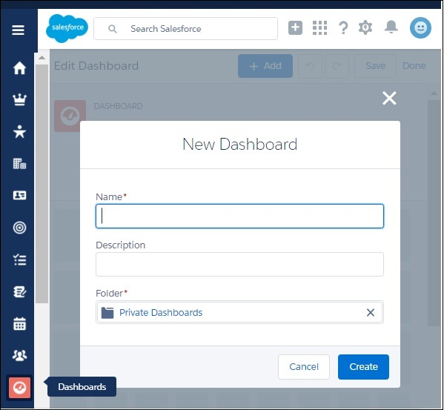

## Step 2

Next we add components to the dashboards. Components are graphical objects which present the summarized or tabular data with visual indicators like colors, etc. In our case we add two components as shown below.

Choose the **Opportunity Amount by Stage** report and present it as a line chart.

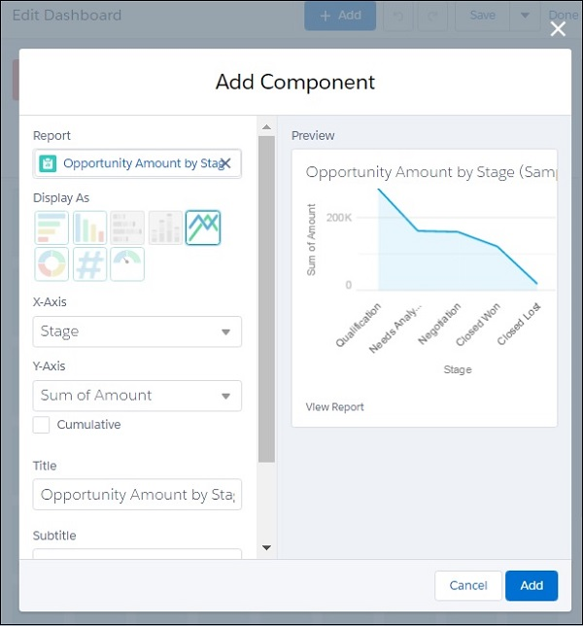

Similarly, we choose another component to be added. Choose the report **Leads Converted All Time** as shown below.

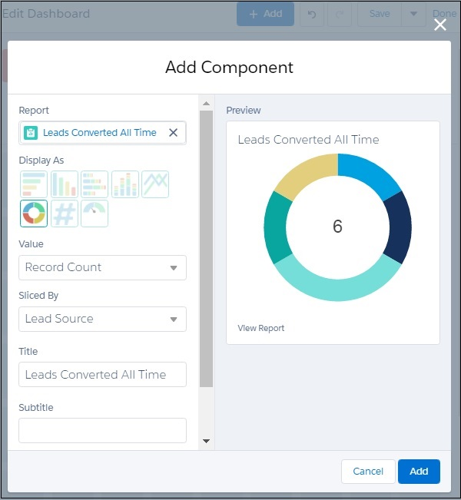

## Step 3

In this step, we see both the components are visible in the dashboard. We can resize the components for better visibility. And there is still more place for additional components.

